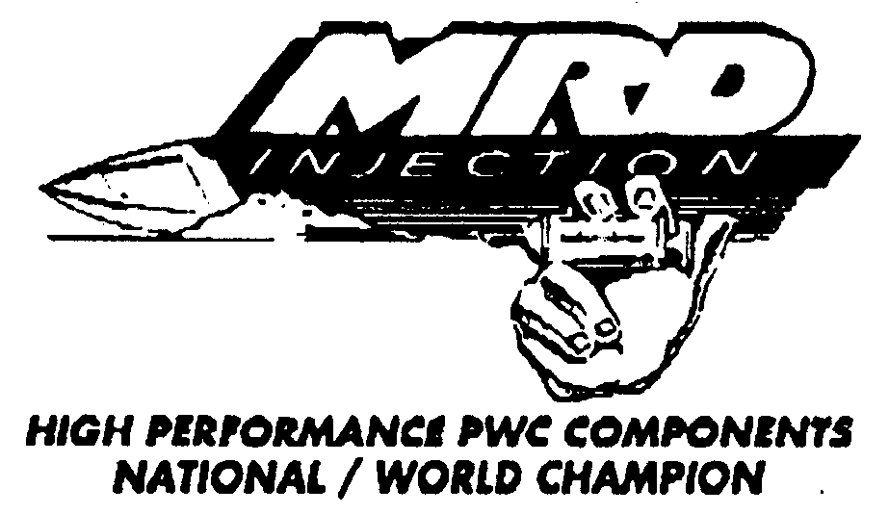

HOW MRD FUEL INJECTION WORKS

MECHANICAL FUEL INJECTION IS SIMPLE AND EASILY ADJUSTED ONCE YOU UNDERSTAND HOW IT OPERATES. THERE ARE THREE MAIN COMPONENTS:
1. CRANK DRIVEN FUEL PUMP
2. METERING VALVE
3. THROTTLE BODY

WHEN ENGINE IS RUNNING FUEL IS DELIVERED TO THE METERING VALVE BY THE FUEL PUMP, WHICH IS TURNING THE SAME RPM AS THE CRANK. THEREFORE IF RPM IS LOW, FUEL PRESSURE IS LOW. IF RPM IS HIGH, FUEL PRESSURE IS HIGH, BECAUSE FUEL PRESSURE RISES AND FALLS WITH ENGINE RPM AND THE METERING VALVE INCREASES AN DECREASES FUEL PRESSURE TO THE NOZZLES ACCORDING TO BUTTERFLY POSITION IN THE THROTTLE BODY. A SMOOTH AND PRECISE FUEL CURVE IS ACHIEVED. WHICH MEANS THROTTLE RESPONSE AT ANY SPEED AND A HARDER PULL THROUGH THE ENTIER RPM RANGE.

NOZZLES MUST BE CORRECT SIZE FOR SYSTEM TO OPERATE, AND RESPOND TO ADJUSTMENT. NOZZLE SIZE IS DETERMINED BY TOTAL CC OF ENGINE. LEVEL OF MODIFICATIONS, SIZE OF THROTTLE BODY 46mm OR 50mm.

T-VALVE: THIS IS THE TOP END ADJUSTMENT, ITS RANGE IS CLOSED TO 3 TURNS OPEN. CLOSED IS RICH, OPEN IS LEAN (OPPISITE OF CARB T-VALVE). MOST ENGINES WILL TUNE BY ADJUSTING THIS ONE ADJUSTMENT, SOME REQUIRE OTHER FINE TUNING.

ADJUSTABLE HEX LINK: THIS ADJUSTMENT IS PRE-SET AND NORMALLY DOES NOT NEED TO BE MOVED. BUT SOME ENGINES REQUIRE LOW END TUNING.

NEVER DISCONNECT ARM FROM METERING VALVE IT IS PRECISELY SET. ADJUSTMENTS ARE MADE BY LOOSENING JAM NUTS AND ROTATING CENTER HEX PIECE. EXTENDING EYES OF LINK RICHENS, SHORTENING DISTANCE BETWEEN EYES LEANS ONLY LOW END. MAXIMUM ADJUSTMENT ONE TURN FROM FACTORY SETTING.

POP OFF: THIS ADJUSTMENT CONTROLS MIXTURE IN FREE REV. CONDITIONS EXPERIENCED IN CHOPPY WATER, WHEN THE BOAT COMES OUT OF THE WATER WITH THROTTLE WIDE OPEN TWO THINGS HAPPEN:
1. LOAD COMES OFF THE ENGINE.
2. FUEL PUMP IS DRIVEN FASTER PUMPING MORE FUEL THAN IS NEEDED.
TO CURE THIS WE USE A POP OFF VALVE TO MAINTAIN PROPER FUEL PRESSURE FOR FULL LOAD CONDITIONS (FLAT WATER) AN DRELIEVE EXCESS PRESSURE NOT NEEDED. RANGE IS 10 PSI TO 15 PSI.

12210 MICHIGAN STREET SUITE 21 ● GRAND TERRACE, CA 92313
_____________________________________________________________________________________________

PHONE (909) 276-2559 ● TECH LINE (909) 824-7174 ● FAX (909) 276-1351

TUNING

WHEN TUNING ANY ENGINE YOU FIRST MUST BE ABLE TO TELL RICH FROM LEAN. AN OVER RICH CONDITION IS ALWAYS MORE NOTICEABLE AT LOW RPM. AN OVERLY LEAN CONDITION IS EQUALLY NOTICEABLE LOW OR HIGH RPM. IT IS POSSIBLE TO HAVE A ENGINE THAT IS RICH AT LOW RPM AND LEAN AT HIGH RPM AT THE SAME TIME AND YOU ALWAYS HAVE TO KEEP IN MIND THAT PROBLEMS WITH OTHER COMPONENTS ON THE ENGINE CAN EFFECT HOW IT IS CARBURATING, SUCH AS MINUTE EXHAUST LEAKS, OR IGNITION BREAK DOWN.

RICH:

AIR TO FUEL RATIOS RICHER THAN 10 TO 1 WILL CAUSE AN ENGINE TO STUMBLE AND NOT FIRE EVERY STROKE AT LOW RPM AND WILL KEEP THE ENGINE FROM REACHING ITS PEAK RPM. (SOUNDS GARGLEY).

LEAN:

AIR TO FUEL RATIOS LEANER THAN 14 TO 1 WILL CAUSE AN ENGINE TO HESITATE AT LOW RPM AND LAY DOWN AND FEEL LIKE IT IS LOOSING POWER AT HIGH RPM, SURGING IS POSSIBLE. (SOUND HOLLOW OR FLAT, NO STUMBLING.)

BECAUSE OF DIFFERENT VARIABLES LIKE AIR DENSITY, HUMIDITY, ALTITUDE OR ENGINE MODIFICATIONS THE BASE SETTING FROM MRD MAY NOT BE PERFECT, SO YOU HAVE TO TUNE YOUR ENGINE BY HOW IT PERFORMS WHICH SHOULD BE NO PROBLEM ONCE YOU UNDERSTAND EXACTLY WHAT AREA OF THE RPM RANCE EACH ADJUSTMENT CONTROLS. (A TACHOMETER IS USEFUL WHEN SETTING THE TOP END).

1. IDLE MIXTURE IS CONTROLLED BY THE METEREING VALVE. IT IS ADJUSTED BY THE
LENGTH OF THE HEX LINK.

2. IDLE SPEED IS CONTROLLED BY THE IDLE STOP, IT IS ADJUSTED BY THE STOP BOLT.

3. LOW TO MID MIXTURE IS CONTROLLED BY THE METERING VALVE AND IS ADJUSTED BY
CHANGING THE RAMP OF THE FLOW SLOT.

4. HIGH MIXTURE IS CONTROLLED BY THE NOZZLE SIZE AND IS ADJUSTED BY THE
T-HANDLE BY PASS WHICH DETERMINES THE FINAL FUEL PRESSURE.

TUNING PROCEDURE

THE ENGINE SHOULD BE TUNED IN THIS MANNER.

1. SET THE TOP END FOR MAX RPM (IF PEAK RPM IS ACHIEVED WITH THE T-HANDLE
1 TO 1 1/2 TURNS OPEN FROM FULLY COLSED THE NOZZLES ARE THE CORRECT SIZE.

2. SET THE IDLE MIXTURE FOR INSTANT CLEAN RESPONSE, WHEN GRABBING FULL
THROTTLE OFF IDLE.

3. CHECK MID RANGE BY SLOWLY PULLING THROTTLE OPEN FROM IDLE TO 1/2 THROTTLE,
IF MID IS RICH INSTALL A LEANER METERING VALVE. IF ENGINE IS LEAN IN THE MID
RANGEIT MAY PING OR DETONATE AND YOU WILL HAVE TO INSTALL A RICHER METER
VALVE.

4. ADJUST POP OFF IF NECESSARY FOR A CLEAN FREE REV IN CHOPPY WATER.

5. IT IS ALWAYS INCE TO HAVE A PRIMER FOR EASY STARTING ON COLD ENGINES.

METER VALVE SIZES

A STANDARD IN MOST TWIN INJECTORS

B STANDARD IN MOST TRIPPLE INJECTORS

C STANDARD IN ROTARY VAVLE ENGINE INJECTORS

B(TP) USED ON TRIPPLE PIPE APPLICATIONS.

TROUBLE SHOOTING

LEAN CONDITIONS:

1. WORN OR DAMAGED FUEL PUMP

2. DIRTY OR CLOGGED FILTER

3. RESTRICTED FLOW OF THE CHECK VALVE CAUSED BY BOOR QUALITY GASOLINE
SWELLING UP THE INTERNAL O-RING.

RICH CONDITONS: **

1. PRESSURE IN FUEL TANK.

2. FUEL LEAK.

3. RESTRICED FLOW OF RETURN CHECK VALVE.

FLOODING:

1. PRESSURE IN TANK.

2. DEBRIS IN ONE OR MORE OF THE CHECK VAVLES OR POP OFF.

LOSS OF PRIME:

1. BAD PUMP SEAL.

2. DEBRIS IN ONE OR MORE OF THE CHECK VALVES OR POP OFF.

3. BAD FRONT CRANK SEAL ALLOWING PRESSURE TO BUILD IN FLYWHEEL CAVITY
PUSHING AIR INTO THE BACK OF THE FUEL PUMP.

**NOTE: THE MOST COMMON CAUSE OF IMPROPER OPERATION, IS THE LACK OF THE INSTALLER TO REMOVE THE CHECK VALVE FROM THE FUEL TANK VENT CIRCUIT, WHICH CAUSES THE TANK TO BUILD PRESSURE.

MAINTEANCE PROCEDURE

WHEN FUEL INJECTION KITS ARE ASSEMBLED OR INSTALLED, NOZZLES CAN BECOME CLOGGED OR RESTRICED BY FORIGN MATERIAL. IT IS ADVISED THAT THE NOZZLES BE REMOVED AND CLEARED AFTER THE FIRST 5 MINUTES OF OPERATION. AFTER THIS IS DONE THE PICK UP SCREEN WILL KEEP ANY DEBRIS OUT OF THE SYSTEM.

NOZZLE CLEANING: RINSE WITH CASOLINE OR CARBURETOR CLEANER. SPRAY THEN BLOW AIR IN ORPHEUS. THIS WILL BLOWN ANY DEBRIS OUT THREADED END OF NOZZLE.

IT IS ADVISED THAT PERIODIC PLUG READINGS BE TAKEN TO INSURE ALL CYLINDERS ARE BURNING CLOSE TO THE SAME. BY COMPARING ALL CYLINDER PLUGS. A POSSIBLE PROBLEM CAN BE FOUND AND FIXED BEFORE ENGINE DAMAGE OCCURS.

AS IS WITH MOST ANY MACHINE MRD INJECTORS WILL OPERATE TO PERFECTION FOR YEARS IF THEY ARE MAINTAINED PROPERLY. ABUSE THEM AND FAILURE IS ALMOST ALWAYS THE RESULT.

THE MAIN CUASE OF FAILURE IS A RESULT OF CORROSION ATTACKING LINKAGE PARTS AND THE EXPOSED PORTION OF THE PUMP SHAFT AND SEAL. AS WITH ANY MOVING PART PERIODIC LUBRICATION IS NEEDED TO AVOID WEAR. A LIGHT COAT OF WD-40 OR SIMILAR WATER DISPLACING SPRAY WILL KEEP WATER DAMAGE TO A MINIMUM.

OTHER THAN NORMAL CLEANING AND LUBRICATION, AND STORING THE CRAFT WITH THE ENGINE COMPARTMENT OPEN SO CONDENSATION CANT OCCURE, NO OTHER CARE NEED BE TAKEN.

IT IS RECOMMENDED THAT MRD FUEL INJECTION SYSTEMS RE SERVICED EVERY 200 HRS TO MAINTAIN THE TOLERANCE OF THE MOVING PARTS.

